***EXCEL PROJECT***

***AMAZON SALES ANALYSIS***

Few are the steps involved in designing the dashboard using excel and dataset of road accidents for a year and months

1.) Firstly, we did the data cleaning.

2.) After data cleaning, data processing was done to the existing datasets.

3.) Now we will proceed to data analysis and data visualization: -

1. **INSERTING A PIVOT TABLE AND DONUT CHART**

(i) select any cell in the dataset.

(ii) Go to insert, and click on pivot table.

(iii) Created tables for sales, KPI’s

(iv) Created donut chart for the tables

**B) CREATING THE DASHBOARD IN NEW SHEET**

(i) Opened a new sheet and remove the gridlines.

(ii) Added some shapes to the sheet and images

(iii)Added the headings for the dashboard

**C)INSERT THE CHARTS FOR THE ANALYSIS**

(i) donut charts for sale ,units, #of cities

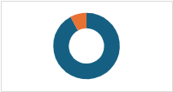

(ii)Line chart for city-wise sales

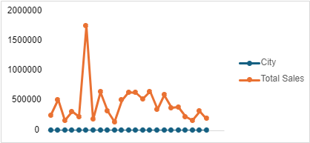

(iii)column chart for state-wise sales

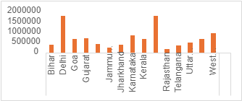

(iv)funnel chart for product-wise units

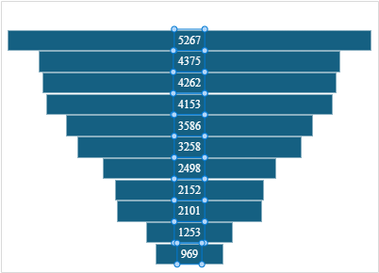

**D) FINAL DASHBOARD**

